**Student Name/ID: Aayush Jwarchan**

**Development Choice: Sublime Text 3 / XAMPP**

**Add Screenshots to show successful setup – project window should show supplied case study**

**In these following pictures I am installing Sublime Text 3 in my pc**.

|  |  |
| --- | --- |
|  |  |
|  |  |

|  |  |
| --- | --- |
| **In the above figure It shows that I have successfully installed Sublime Text 3 in my PC.** | **The following picture shows the installation process of Xampp in my Pc.** |
|  |  |

|  |  |
| --- | --- |
|  |  |
|  |  |
|  | **The above figures shows that I have successfully installed Xampp in my Pc.** |

**The following pictures will show that Sublime Text 3 is successfully installed in my Pc. And it is running properly.**

|  |  |
| --- | --- |
|  |  |

**The following pictures shows us that Xampp is successfully installed and is correctly running.**

|  |  |
| --- | --- |
|  |  |

**PHP Version being used: ‘PHP 8.0.3 ’**

**XDebug installed: Yes**

**The following pictures shows that Php is successfully installed locally and is installed in Xampp also.**

|  |  |
| --- | --- |
|  |  |

**The following picture shows that Xdeubg is successfully installed and is running properly in Sublime Text 3.**

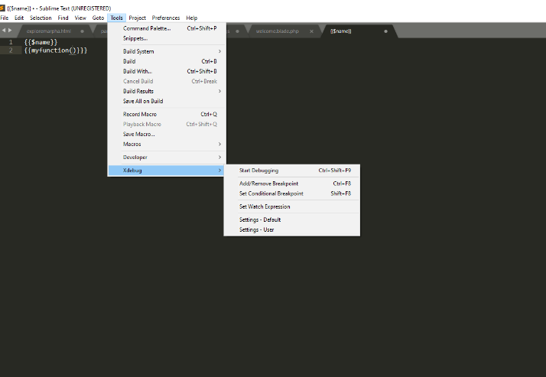

**Git account created and used:**

**https://github.com/aayush2456/repository-of-component1.git**